The Trade Desk and ROKU

2023

Contents

The Trade Desk Inc 4

Tech Stack 4

Unified ID 2 4

Kokai 5

Galileo 5

OpenPath 5

Partnerships 5

Revenue 6

Platform operations 6

Sales and marketing 6

Technology and development 6

General and administrative 6

ROKU 6

Business Overview 6

CTV Ad Market 6

US Advertising Industry (Digital + Traditional) 7

Digital Advertising 7

Traditional Advertising 7

The Connected TV Ecosystem 8

Roku as an Operating System 9

Differentiation 9

Strategy 9

Products 9

Monetization 9

Bottom Line 10

Competition 10

Market Share 10

Roku as a Content Publisher – The Roku Channel 11

The Basics 11

Strategy 11

Engagement 11

Competition 11

Incremental Ad Inventory 12

TRC Economics / Reach 12

CTV Ad Tech – Roku’s DSP (OneView) 12

OneView 12

Opportunity 12

CTV / OTT Ad Placement Today 12

ROKU 12

Dual Sided Fly Wheel 13

INVESTMENT RISKS 14

Competition 14

Consumer Acquisition 14

Advertiser Acquisition 14

Content Attraction 14

Content Generation 14

Roku Products and Services 14

Streaming Players 14

Roku TVs 15

Content Distribution 15

Advertising 16

Sales & Marketing Team 16

Retail Distribution 16

Streaming Player Holidays Promotion 16

Technology Overview 17

Roku OS and TVs 17

OneView 17

GROWTH DRIVERS 17

Increasing Active Accounts 17

Affordability 17

Roku OS Simplicity 17

TV Selection 18

International Expansion/White Label Players 18

Growing Streaming Hours 18

Content Selection 18

Roku Direct Publisher 18

The Roku Channel 18

Quibi Acquisition/Roku Originals 18

Roku Brand Studio 18

Monetization 18

OneView 19

Direct-to-Consumer and SMBs 19

Dynamic Ad Insertion Technology 19

Roku Pay 19

# The Trade Desk Inc

*(Reference - 20230906 - William Blair Research - TTD - Initiation - Proprietary Technologically Forward Platform - 23 pages.pdf)*

The Trade Desk is a leading player in the global advertising technology sector, providing a self-service,

platform that enables clients to purchase and manage data-driven digital advertising campaigns.

The company’s platform integrates various advertising formats, including display, video,

audio, native, and social, across a multitude of devices, such as computers, mobile devices, and TV.

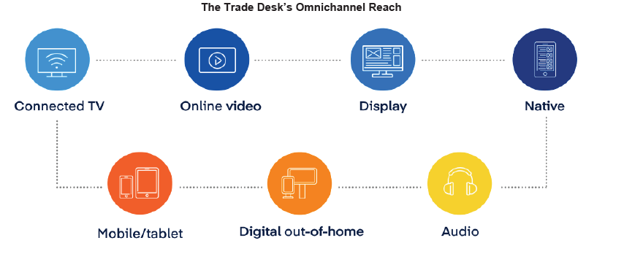

The Trade Desk’s demand-side platform (DSP) generates a little less than 90% of its total platform.

spend from North America

## Tech Stack

An overview of several capabilities of The Trade Desk’s technology stack is provided below –

### Unified ID 2

This open-source identity framework allows users to forgo the use of third-party cookies for ad targeting, allowing for more effective, privacy-conscious marketing –

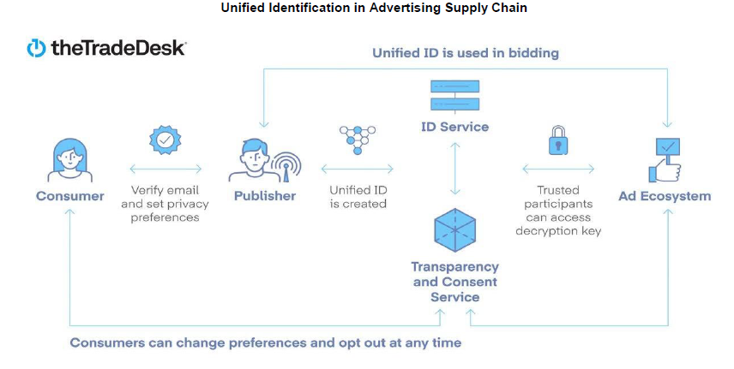

### Kokai

In June 2023, The Trade Desk launched Kokai, which leverages major advances in distributed artificial intelligence (AI). Kokai builds on Koa, which was launched in 2018; Kokai leverages the power of Koa’s AI throughout multiple aspects of media buying within The Trade Desk’s platform.

Galileo

Announced on January 5, 2023, this first-party data integration tool enables cross-channel identity solutions like UID2, customer relationship management, and other data to enable audience matching (using online and offline data to better target existing customers).

### OpenPath

To further enhance supply, The Trade Desk introduced OpenPath in early 2022, a tool primarily designed to drive publisher supply to the open internet and streamline the ad supply chain. OpenPath does not, however, offer yield management services, making it less accessible to smaller companies with limited yield management resources. In contrast, larger entities stand to benefit significantly from this tool, as it enables them to receive bids directly through The Trade Desk’s platform.

## Partnerships

The Trade Desk works with many inventory, data, and advertising partners to provide comprehensive

ad buying solutions.

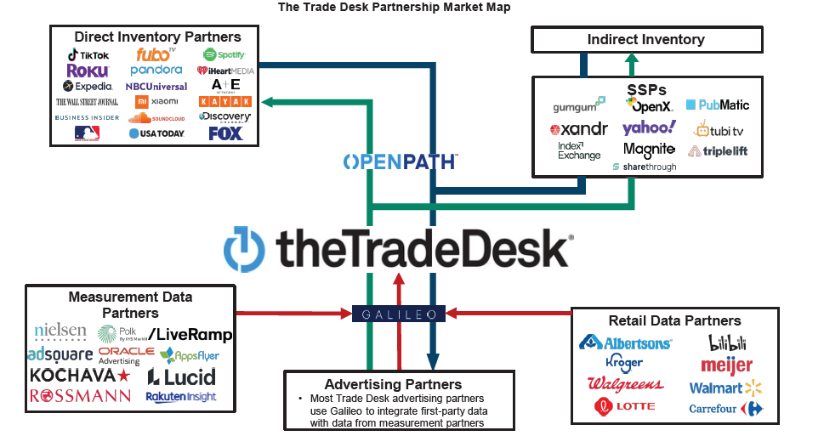

At The Trade Desk’s investor day in October 2022, founder and CEO Jeffrey Green indicated that the

broader television advertising market is roughly $250 billion. Of that total, CTV represents roughly $16 billion.

The Trade Desk operates in a highly competitive landscape that includes large technology companies such as Google Ad Exchange, Amazon, and Meta. The Trade Desk’s positioning as a DSP allows it to leverage its existing base of advertisers to gain additional advertising inventory from providers that would historically not share inventory with anyone outside their ecosystem.

## Revenue

Revenue is generated from clients leveraging the company’s platform to purchase advertising inventory, data, and other add-on features. Clients are charged a platform fee, which is a percentage of the client’s purchases through The Trade Desk’s platform. Clients are also invoiced for the cost of advertising inventory purchased, along with any data and add-on features.

## Platform operations

These expenses include costs related to the hosting of The Trade Desk’s

platform, including “internet traffic” correlated with the viewing of impressions or queries per

second, the purchasing of data to improve the company’s platform, and costs associated with providing client support.

## Sales and marketing

Sales and marketing expense comprises personnel costs; costs associated with market development programs, marketing events, advertising and promotional activities; and other associated expenses. Personnel costs include employee commissions, which are expensed when they are incurred.

## Technology and development

These expenses primarily consist of personnel costs, third-party consulting costs (related to the ongoing development of The Trade Desk’s platform and the integrations with advertising/data inventory suppliers), and the amortization of capitalized third-party software.

## General and administrative

General and administrative expenses primarily comprise personnel costs, costs attributable to accounting and legal professional service fees, and credit loss expenses. This expense line item also includes stock-based compensation expenses related to the CEO performance option.

As of June 2023, Magna Global estimated 2023 global ad spend to be roughly $840 billion, about $580 billion of which is spent in the broader internet categories (including search, display, social, online video, and other). Eventually, most (if not all) of the $840 billion global ad market will be digital, up from roughly 69% today. Further, Magna estimates that the global advertising market will surpass $1 trillion by 2027.

# ROKU

*(Reference - 20221111 - Jefferies - ROKU - Initiation - Initiating Coverage CTV Growth - 28 pages.pdf)*

## Business Overview

Roku's flywheel is built on OS for CTV via partnerships and hardware, an ad platform including OneView is DSP, and the Roku channel which is a FAST service that combines 50/50 rev share licensed IP as well as limited original content. Together it drives ROKU's position to be a leading player in television as it captures share of shifting dollars towards CTV from hardware to subscriptions to ad dollars.

## CTV Ad Market

CTV to be the fastest growing digital ad segment w/ an 18% CAGR for 2022-26, reaching ~$36B by '26. New, premium AVOD services plus established streaming engagement should drive advertisers to CTV inventory; digital ad wallet growth and dollars shifting to CTV.

ROKU was early in building a business that is central to CTV and was one of the primary architects in driving the shift from linear to CTV. We believe ROKU will capture some economics as this shift continues, and we see the TAM being north of $70B over the long term.



## US Advertising Industry (Digital + Traditional)

### Digital Advertising

We expect digital advertising to grow at a ~10% CAGR for 2022-26, reaching >$300B by 2026 –

* Search is the largest ad format at >45% of the market.
* CTV is the fastest growing segment - ~18% CAGR for 2022-26, reaching ~$36B by 2026.
* The progression of streaming and new, premium AVOD services (Netflix & Disney+) should result in TAM expansion and dollars shifting to CTV, which helps offset macro headwinds.

### Traditional Advertising

We see Linear TV as a >$60B ad market today, declining ~2% annually through 2026.

* The Connected TV Advertising TAM
* The connected TV advertising market is a function of -

1. Digital ad wallet expansion as attractive inventory becomes available vs SVOD offerings and
2. Linear TV ad dollars shift over as streaming consumption surpasses linear TV and anchor content, such as sports, shifts to CTV.

## The Connected TV Ecosystem

Advertising dollars are split amongst 3 main market participants –

1. Content Publishers - Netflix, The Roku Channel, Peacock, etc.
2. TV Operating Systems – Roku, Android TV, Tizen OS (Samsung), etc.
3. Ad Tech – TTD, OneView, Magnite, PubMatic, Xander, etc.

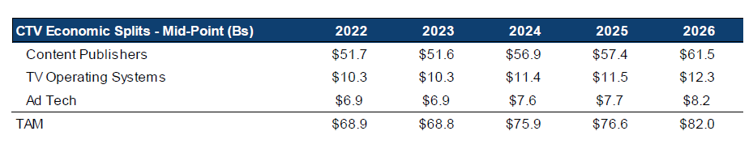

## Roku as an Operating System

### Differentiation

Purpose built operating system for TVs.

* License the Roku OS to third-party OEMs – creating an OS is capital intensive and it requires sizable market share to be profitable.

### Strategy

Increase active accounts by adding partners and entering new markets, grow engagement through superior UI and overall user experience, monetize the platform.

### Products

Roku sells CTV dongles that turn dumb TVs into smart TVs and licenses its OS to third-party OEMs.

* TV brand partners include TCL, Hisense, Philips and more.
* Roku typically does not charge for its OS license.

### Monetization

Roku looks to take 30% of ad inventory as the standard, pre-negotiation terms – there is a ton of negotiating and no two content publishers are the same.

* A % of ad inventory
* Ad inventory on the Roku platform (M&E)
* Content for The Roku Channel
* Search and discovery promotions
* Roku payment processing for SVOD services
* Buttons on the Roku remote

### Bottom Line

Roku unlikely to capture 30% from major content publishers as an OS fee but can make up some of that through platform monetization.

## Competition

Roku competes with two different groups in the TV OS market: major tech companies and traditional OEMs. However, certain companies within each group are expanding / shifting their strategy, which is blurring the competitive landscape. We outline the two groups below –

* CTV/ SMART TV Companies

* OEM Companies

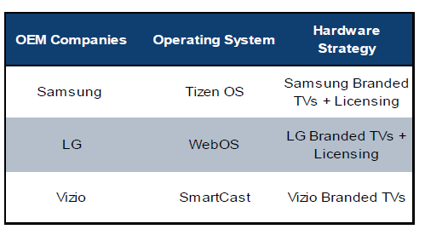

## Market Share

Roku has a dominant share of big screen streaming in N. America at ~40% (1Q22) and, given the maturity of streaming in N. America vs other regions, a 30.8% share of all big screen streaming globally.

* In fact, with 77% of global streaming happening on the big screen, Roku sees ~24% of all streaming on its platform.

However, Roku is not top 5 in any of the other 5 regions.

* Android TV is #1 in 3 of the 6 regions and in the top 5 in 5 of them.
* Amazon Fire TV is top 5 in 4 of the 6 regions and 2nd globally because of its presence in N. America.
* Samsung TV is most relevant in N. and South America right now, but 3rd globally.

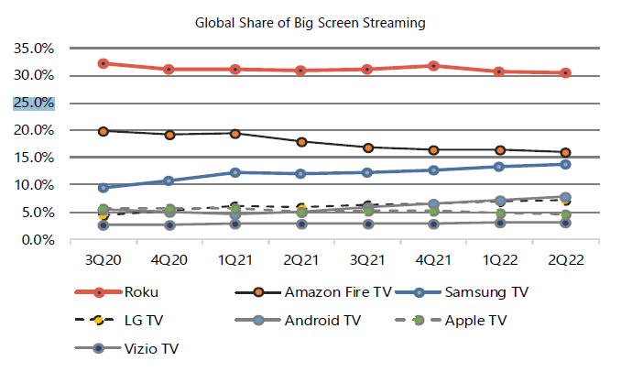

## Roku as a Content Publisher – The Roku Channel

### The Basics

The Roku Channel (TRC) is a free ad supported streaming TV (FAST) offering that is exclusive to Roku account members.

### Strategy

The Roku Channel is a tool for engagement and monetization of the Roku platform. As the operator, Roku can drive engagement towards TRC through the user interface (UI).

### Engagement

The Roku Channel recently became a top 5 channel on the Roku platform in terms of “Streaming Hour” engagement (1Q22) – impressive when you consider the streaming competition.

### Competition

There is no shortage of content publishers / distribution platforms, and the market is only getting more competitive as SVOD-only offerings roll out hybrid AVOD services.

* Hybrid AVOD – the well-known streaming services such as Hulu, Paramount+, Peacock, HBO Max, YouTube, Prime Video, ESPN+ and now Netflix & Disney+.
* AVOD / FAST – services that directly compete with The Roku Channel and may come with the TV OS; Xumo, Tubi, Pluto, Freevee.
* MVPD – content aggregators that offer live, linear content through connected TV; Hulu Live, YouTube TV, Sling etc.

### Incremental Ad Inventory

Netflix and Disney+ ad tiers should help accelerate the shift of ad dollars to CTV. SVOD only offerings have been helping to drive streaming engagement higher w/out giving advertisers the opportunity to participate, resulting in lagging ad monetization.

### TRC Economics / Reach

As a reminder, the majority of TRC content is part of a 50/50 rev share agreement, which effectively cuts Roku’s publisher TAM in half. Incremental operating leverage could be achieved through more fixed licensing and/or original content, but that would deviate from Roku’s conservative approach to engagement vs content on TRC.

## CTV Ad Tech – Roku’s DSP (OneView)

### OneView

Roku’s ad buying platform that is built for TV streaming.

### Opportunity

CTV advertising will catalyze a move away from the set pricing, content-based ad buying that exists on linear TV and push advertisers towards programmatic, audience-based buying.

### CTV / OTT Ad Placement Today

The majority of advertising in OTT/CTV still seems to be direct deals or insertion orders vs programmatic – Xandr only selling NFLX ads direct right now.

# ROKU

*(Reference - 20220726 - Raymond James - ROKU - Initiation - ROKU Initiating Coverage of - 32 pages.pdf)*

Roku participates in a $399B TAM broken down into Smart TVs ($117B), subscription video on demand (SVOD: $82B), video advertising ($183B which includes AVOD & FAST: $40B), transaction video on demand (TVOD: $11B), and streaming players ($7B).

Within hardware, Roku provides streaming players which according to Statista is expected to be $7.3B in 2022 and grow at a CAGR of 11.3% through 2026. While Roku only licenses its operating systems to smart TV OEMs currently, we expect Roku could eventually manufacture its own smart TV, which according to Valuates Reports is expected to be a $116B market in 2022 growing at a 1.8% CAGR through 2027

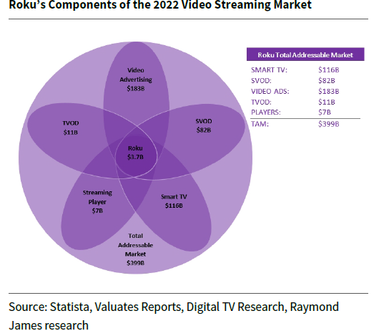

## Dual Sided Fly Wheel

Roku has a dual sided flywheel that focuses on the consumer product and the consumer experience –

* On the product side the consumer is driven to the platform due to its ease of use and affordability which attracts retailers to offer Roku TVs.
* OEMs are attracted to partner with retailers due to the sales, premium low-cost OS and helpful manufacturing support from Roku, which in turn provides more selection of affordable Roku products for the consumer.
* On the experience side, consumers are driven to the platform due to wide variety and diversity of the Roku platform’s content selection.

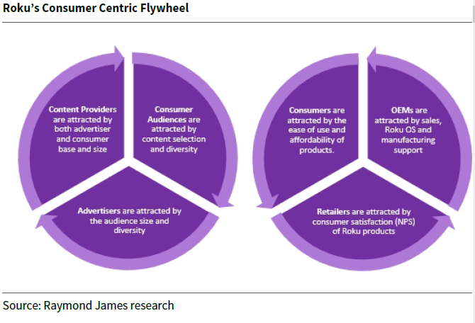

## INVESTMENT RISKS

### Competition

The company faces competition from a wide range of competitors, including TV OEMs (e.g., Samsung, LG, Vizio), service operators (e.g., Comcast), large tech companies who develop streaming devices (e.g., Apple, Amazon, Google) and content publishers (e.g., Netflix, Amazon, YouTube, HBO, etc.).

### Consumer Acquisition

Attracting users to the Roku platform is key to Roku’s long-term success. Roku must maintain several relationships to continue to successfully attract users including relationships with TV OEMs, service operators, and content publishers.

### Advertiser Acquisition

Advertisers use Roku’s demand side platform, Oneview, to access Roku’s ad inventory and ultimately its audience. Roku must effectively target, and measure advertiser ad spend in order to provide quality return on ad spend (ROAS) to advertisers.

### Content Attraction

A small amount of content publishers has made up a large majority of streaming on Roku. In 2021, three streaming services made up +50% of streamed hours on Roku.

### Content Generation

Roku acquired ~75 Quibi shows in 2021 and now maintains the content as Roku Originals. Additionally, the company is planning a slate of new Roku Originals.

## Roku Products and Services

Roku offers a variety of products and services to consumers, content publishers, and advertisers including streaming player devices, smart TVs, audio products, free third-party and original content, digital advertising, content distribution, and licensing agreements.

### Streaming Players

Roku’s business originated when Netflix spun off its streaming player project to Roku in 2008 after realizing the device could restrict licensing deals with competing streaming devices. The streaming players powered by Roku OS enable streaming for non-streaming capable TVs at a much lower price for consumers rather than upgrading to expensive smart TVs. Roku is on its 10th generation of streaming player devices after initially launching in 2008. The devices range from a simple device and remote at $24.99 to a 4K audio streaming bar with voice remote at $179.99. Roku sells most of its players through brick-and-mortar retailers like Best Buy, Target, and Walmart and online retailers like Amazon. In 2020 and 2021, Amazon, Best Buy, and Walmart accounted for 69% of player revenue.

Roku Streaming Player Options

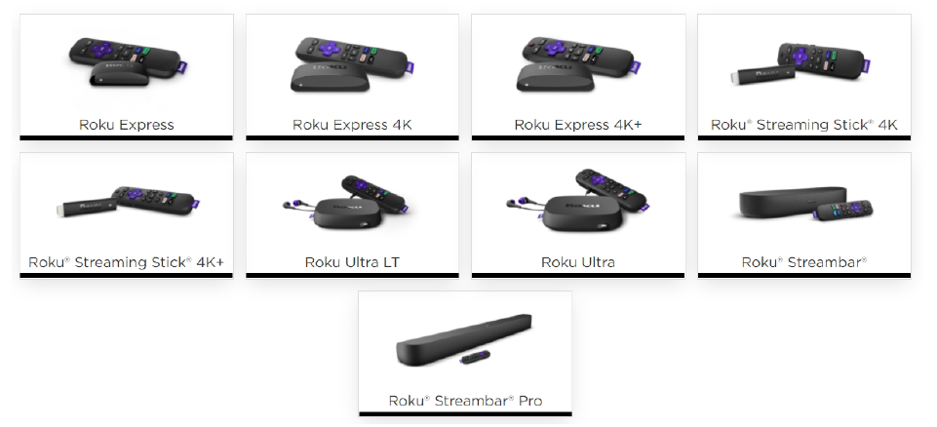

### Roku TVs

Roku launched its first branded smart TVs powered with Roku OS in 2014 and now is the #1 selling smart TV operating system in the U.S., representing 1 in 3 smart TVs sold. Roku licenses its operating system to TV original equipment manufacturers (OEMs) growing Roku’s user base. Roku has hundreds of smart TV models through its OEM partners.

Roku TV OEM Partners

### Content Distribution

Roku provides a platform to distribute and monetize streaming content in four formats: transaction video on demand (TVOD), subscription video on demand (SVOD), ad-supported video on demand (AVOD), and free ad-supported streaming TV (FAST). Content publishers can use Roku Pay to create invoices and bill users for purchases and rental subscriptions. Roku takes a revenue share of transaction and subscription purchases. Roku Pay also allows one payment point for users to simplify their payment process.

### Advertising

Roku provides advertisers (content publishers, brands, agencies) access to the cord cutter audience that is often no longer accessible through linear TV. It launched its self-service ad portal in 2016 and acquired a demand side platform, Dataxu, in 2019 to enhance its ad buying experience. In 2020, the company rolled out its new Ad platform, OneView, which leverages the Dataxu asset, and in 2021, it launched Roku Brand Studio, which enables advertisers to offer more innovative ads including ads within the user interface, interactive ads, and branded content series.

## Sales & Marketing Team

Roku’s sales and marketing is divided into 6 teams –

1. Agency holding companies and Fortune 500 brands.
2. Independent agency and mid-market clients.
3. Content publishers and entertainment brands.
4. Performance and direct to consumer brands.
5. International markets.
6. Local advertising.

### Retail Distribution

The majority of streaming players, audio products, and Roku TV models are sold through brick-and-mortar retailers and ecommerce platforms. In 2020 and 2021, Amazon, Best Buy, and Walmart accounted for 69% of player revenue. The company’s sales and marketing teams assist with in store marketing and product forecasting for its retailers.

### Streaming Player Holidays Promotion

During the fourth quarter holiday season, Roku promotes is streaming players with significant discounts to average selling prices of its streaming players through retailers with the purpose of growing its active accounts.

## Technology Overview

### Roku OS and TVs

The Roku operating system, Roku OS, was designed specifically for TV streaming unlike other operating systems that were built for mobile and adjusted for TV streaming. The Roku OS was also designed intuitively and for simplicity when it comes to system setup, navigating the platform, and software update automation.

### OneView

In 2020, Roku launched OneView, its new Ad platform, for advertisers to access more cord cutters, measure performance, and manage their entire campaign all in one place. In 2021, Roku acquired Nielsen’s Advanced Video Advertising (AVA) business which included video automatic content recognition (ACR) and dynamic ad insertion (DAI) and incorporated it into its OneView platform.

## GROWTH DRIVERS

### Increasing Active Accounts

Roku provides a TV streaming platform that is affordable, simple to use and has a wide variety of products to select from.

### Affordability

Roku sells it streaming players and other devices mostly at cost to help grow its user base. Additionally, the company provides reference designs when licensing out its OS to TV OEMs so hardware cost remains low, and OEMs can competitively price smart TVs for consumers.

### Roku OS Simplicity

Roku takes pride in the fact that its streaming platform is easy to use and navigate. Roku users have cross-channel search capabilities, can manage their streaming services and budgets in one platform, can enable one-click subscriptions, and are provided content recommendations based on their viewing preferences.

### TV Selection

By partnering with TV OEMs, Roku is able to offer a wide selection of Roku branded TVs and enable the ability of consumer choice when selecting a TV. Roku also enables consumer choice through the Roku TV Ready program, which enables partnered audio products to work seamlessly with Roku branded TVs.

### International Expansion/White Label Players

The switch to streaming from linear TV is a global phenomenon. In 2015, Roku first entered Mexico with its players and partnered with TCL to provide Roku branded TVs in the country and then expanded to other OEMs. With Roku’s low price point, simplicity of use, and wide selection of products, it looks to expand in other markets (e.g., Brazil, Germany, UK, Chile, and Peru) especially as price sensitive international markets look for a wide selection of AVOD and FAST offerings on a streaming platform.

### Growing Streaming Hours

Roku has grown streaming hours from 9.4B in 2016 to 73.2B in 2021 and grown streaming hours per account per month from 69.1 hours in 2016 to 109.6 hours in 2021.

### Content Selection

Roku offers 500,000+ free and paid movies/TV episodes, thousands of apps/streaming services, and 250+ live TV channels on its platform. Roku maintains relationships with content publishers and looks to attract more content/publishers to its platform by enabling them to publish streaming channels quickly and easily.

### Roku Direct Publisher

Direct Publisher is Roku’s free streaming channel publishing tool, which enables publishers to create a branded Roku channel quickly and easily. The tool provides an easy step-by-step guide for content owners/publishers to customize and create their streaming channel without writing any code.

### The Roku Channel

The Roku Channel is Roku’s own streaming channel that provides user access to free, ad-supported movies and shows on-demand, live-streaming linear channels, original content, and premium subscriptions. The Roku Channel has 80,000+ free movies and TV shows, 200+ free live linear TV channels and 10,000+ family friendly free ad-supported content.

### Quibi Acquisition/Roku Originals

In January 2021, Roku acquired ~75 shows from Quibi for under $100M and relaunched the shows in May 2021 on The Roku Channel as Roku Originals.

### Roku Brand Studio

In 2021, Roku launched the Roku Brand Studio to enable brands to provide more innovative ad experiences with sponsored ads in the user interface, interactive video ad, branded content series, shoppable ads and brand experiences.

## Monetization

Roku monetizes its user base through advertising and user purchases made on its platform. The company’s demand side platform (DSP), OneView, and billing solution, Roku Pay, enable those advertisements and user purchases.

### OneView

Roku predominately monetizes its platform through its DSP, OneView, which is the only place to access ROKU data and The Roku Channel ad space. Roku obtains first-party data through its direct relationship with users. Advertisers can measure the effectiveness of their ad spend (ad impressions serve, click through rates, video completion rates) and ROAS through the OneView platform.

### Direct-to-Consumer and SMBs

In 2021, Roku announced a tool for Shopify merchants to build, buy, and measure TV streaming advertising campaigns on the Roku platform. The company is working to expand is total addressable market of advertisers to direct-to-consumer and small/medium business (SMBs) who primarily spend advertising on digital media (i.e., search) and social media.

### Dynamic Ad Insertion Technology

In 2021, Roku acquired Nielsen’s video automatic content recognition and dynamic ad insertion technologies. These technologies allow Roku to recognize legacy TV placed advertisements and replace the ad with a targeted ad for that user in real time.

### Roku Pay

Roku’s billing solution, Roku Pay, simplifies user subscription signups by centralizing streaming billing in one place for users which helps drive subscription purchases and increase retention for content publishers. Roku Pay assists content partners with billing for movie rentals, managing subscriptions, and customer invoices.

## Roku Business Model Overview –

[Source](https://businessmodelanalyst.com/roku-business-model/)

## Roku Monetization Model Overview

## Roku Company Overview

